CS 255 System Design Document Template

UML Diagrams

UML Use Case Diagram
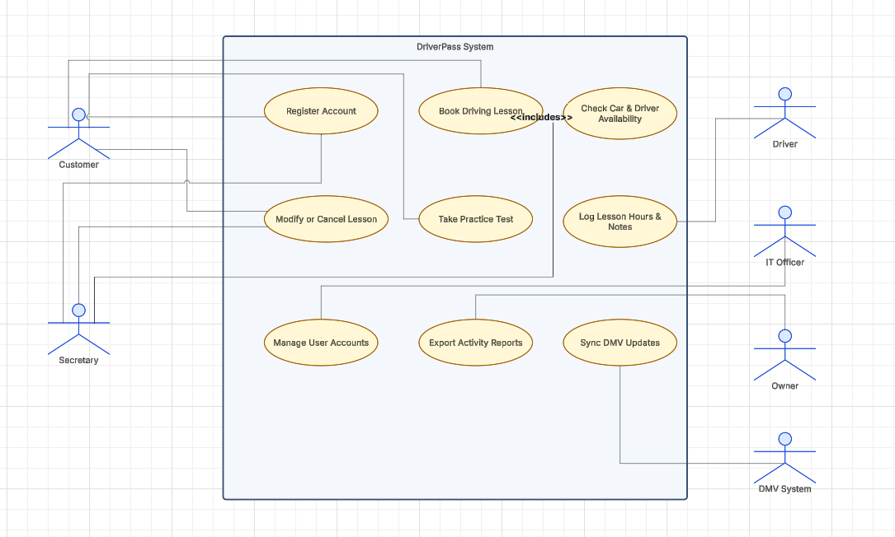

UML Activity Diagrams

Activity Diagram 1: Book Driving Lesson
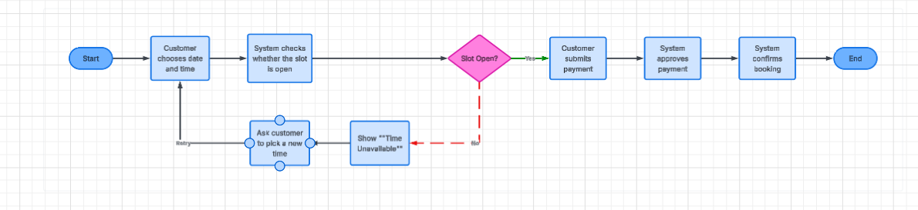

Activity Diagram 2: Log Lesson Hours & Notes

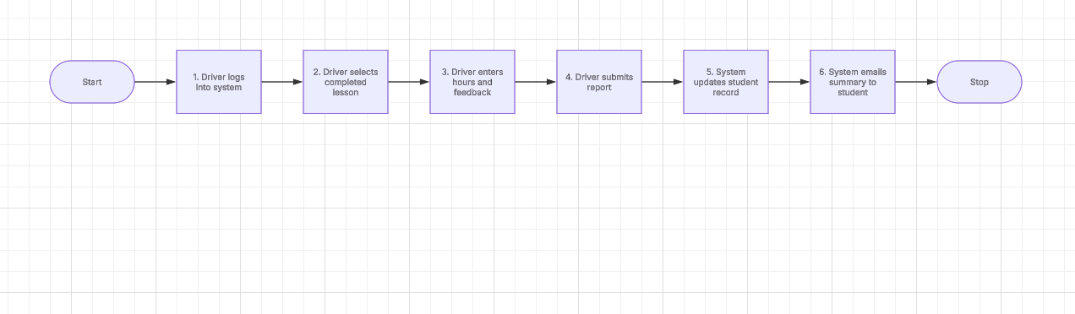

UML Sequence Diagram
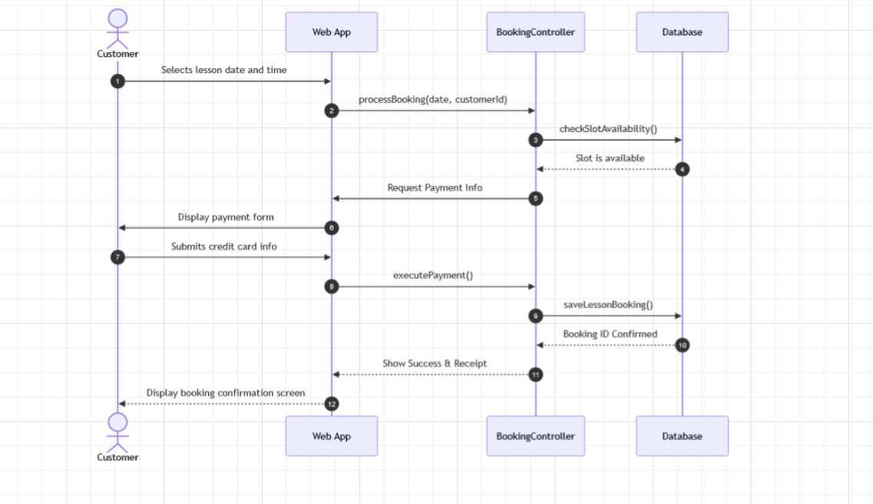

UML Class Diagram
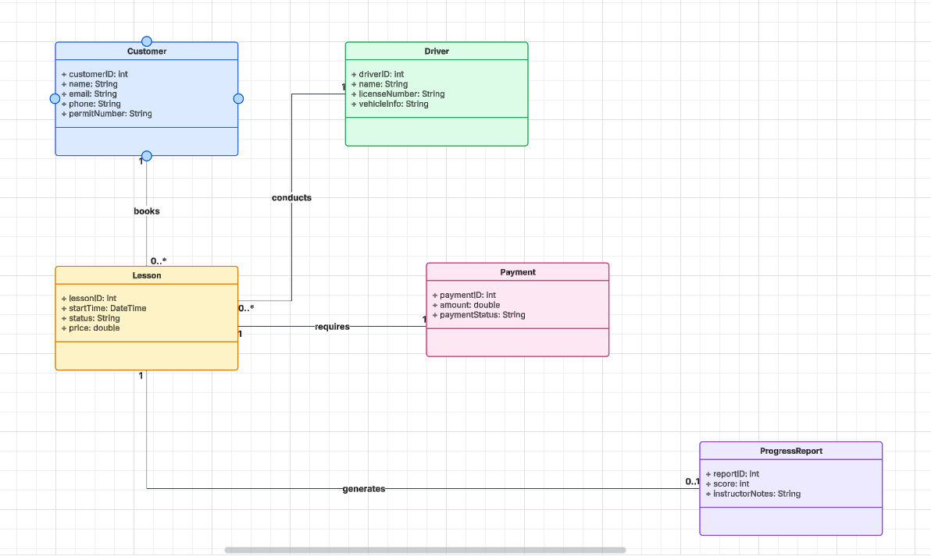

Technical Requirements

Based on the system design for DriverPass, here are the technical requirements:
- Hardware: We need cloud servers (like AWS or Azure) with at least 16 GB of RAM so the booking site doesn't lag when everyone tries to log in at once. We also need a reliable cloud database server with solid-state drives for quick data loading, plus regular daily backups. For users, standard smartphones, tablets, or computers with a normal web browser will work fine.
- Software and Operating Systems: The servers should run a secure, lightweight operating system like Linux. For storing user accounts, lesson schedules, and payment info, we will use a standard relational database like PostgreSQL or MySQL. The backend will use modern web frameworks (like Node.js or Python), and the front end will use HTML, CSS, and JavaScript so it looks and works great on mobile phones.
- Tools and Integrations: We are using Lucidchart to build our UML diagrams for system design. For payments, we will hook up a secure third-party processor like Stripe or PayPal so we don't have to store credit card numbers on our own servers. We will also use tools like Twilio and SendGrid to automatically text and email lesson reminders to students and instructors.
- Infrastructure and Security: The system will live in the cloud with a 99.9% uptime goal. All traffic between the user and the website will be encrypted using HTTPS/TLS. We will also use web firewalls and load balancers to keep the site safe from cyber attacks and keep traffic running smoothly.

